Shiny in R vs Shiny in Python - Quick Reference

1: Create a Conda Environment & Install Shiny

# Create a new Conda environment for Shiny, open your Anaconda Prompt (on Windows) or #terminal (on macOS/Linux) and run the following command:

# Add the dependencies you want example: pandas numpy matplotlib with pip or conda-forge

>>conda create -n shiny_env python=3.9 shiny pandas numpy matplotlib pip -y

# OR use conda-forge channel

>>conda create -n shiny_env -c conda-forge python=3.9 shiny numpy matplotlib pandas

# Activate the Environment

>>conda activate shiny_env

2: Create your App.py

Like in R, in Python we need an app.py

Option A: Use the shiny CLI

# In the same environment, run:
>>shiny create

Option B: Manually create app.py

Create your project folder if needed and manually create app.py:

3: Navigate into your app directory & run your Shiny App locally

>> shiny run app.py --reload --launch-browser

# --reload restarts the app automatically on code changes
# --launch-browser opens the app in your default browser automatically
# By default, it opens at http://127.0.0.1:8000

Core Concepts Comparison
Concept | Shiny in R (app.R) | Shiny in Python (app.py) | Notes
App Structure | ui object, server function, shinyApp() call | ui object, server function, App() call | Both define UI and server logic, then combine them.
UI Definition | Uses fluidPage(), sidebarLayout(), tabsetPanel(), etc. | Uses ui.page_fluid(), ui.layout_sidebar(), ui.navset_tab(), etc. | Python uses ui. prefix for all UI functions.
Server Logic | function(input, output, session) { ... } | def server(input, output, session): ... | Python uses def for function definition.
Inputs | input$inputId | input.inputId() | Python inputs are accessed as methods (()).
Outputs | output$outputId <- renderPlot({ ... }) | @output @render.plot def outputId(): ... | Python uses decorators (@output, @render.<type>) for outputs.
Reactivity | reactive({...}), observe({...}), eventReactive({...}) | @reactive, @observe, @event(input.id) | Python uses decorators for reactive expressions and observers.
Rendering | renderPlot(), renderTable(), renderText() | render.plot(), render.table(), render.text() | Python uses render. prefix for all render functions.
Dependencies | library(shiny), library(ggplot2) | from shiny import App, ui, render, import pandas as pd | Python uses from ... import ... or import ... as ....
Running App | runApp() | shiny run app.py (CLI) | Python typically run from command line.
HTML Tags | h1(), p(), div() | ui.h1(), ui.p(), ui.div() | Python uses ui. prefix.

Common UI & Server Elements
Feature | Shiny in R Syntax | Shiny in Python Syntax
App Init | shinyApp(ui = ui, server = server) | app = App(app_ui, server)
Page Layout | fluidPage(...) | ui.page_fluid(...)
Sidebar Layout | sidebarLayout(sidebarPanel(...), mainPanel(...)) | ui.layout_sidebar(ui.panel_sidebar(...), ui.panel_main(...))
Text Input | textInput("id", "Label") | ui.input_text("id", "Label")
Numeric Input | numericInput("id", "Label", value = 0) | ui.input_numeric("id", "Label", value = 0)
Slider Input | sliderInput("id", "Label", min=0, max=100, value=50) | ui.input_slider("id", "Label", min=0, max=100, value=50)
Select Input | selectInput("id", "Label", choices = c("A", "B")) | ui.input_select("id", "Label", choices = ["A", "B"])
Button | actionButton("id", "Click Me") | ui.input_action_button("id", "Click Me")
Plot Output | plotOutput("plot_id") | ui.output_plot("plot_id")
Table Output | tableOutput("table_id") | ui.output_table("table_id")
Text Output | textOutput("text_id") | ui.output_text("text_id")
Access Input | input$id | input.id()
Render Plot | output$plot_id <- renderPlot({ ... }) | @output @render.plot def plot_id(): ...
Render Table | output$table_id <- renderTable({ ... }) | @output @render.table def table_id(): ...
Render Text | output$text_id <- renderText({ ... }) | @output @render.text def text_id(): ...
Reactive Value | reactiveVal(0) | reactive.Value(0)
Reactive Exp. | my_reactive <- reactive({ ... }) | @reactive def my_reactive(): ...
Observer | observeEvent(input$button, { ... }) | @event(input.button) def _(): ...

Example App for comparison R-Python

Let's walk through the conceptual steps for building a simple app that takes a number from a slider and displays its square.

User Interface (UI)

In R:
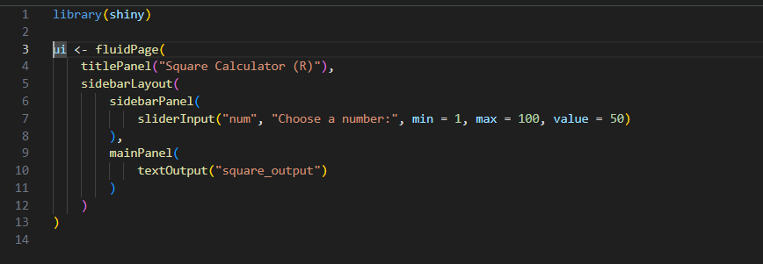
In Python:
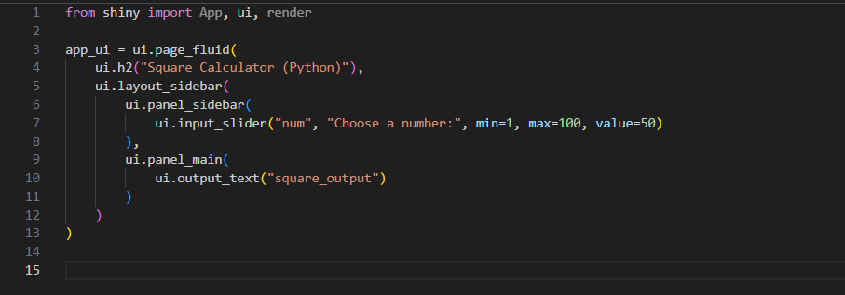

Server

In R:
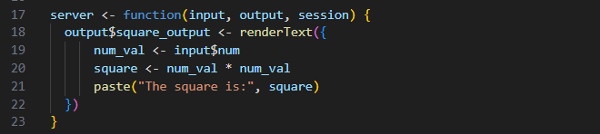

In Python:

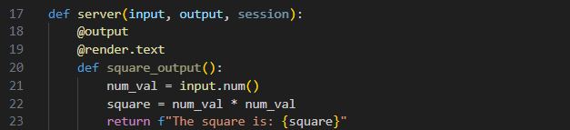

Session

In R:

In Python:

